Sample Key Messages for Outreach
Outreach messages related to risk mitigation can be developed with community leaders, who can help to amplify messages within communities.

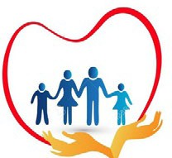
All assistance is free! No one has a right to touch you, or demand money or favors or sex in exchange for services.

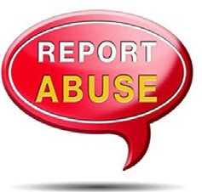
If you see or hear anyone asking for money, sex or favor in exchange for any service you have a right to report it. Add information on locations/ focal points for reporting.

Individuals who may be vulnerable – unaccompanied young people, pregnant women, persons with disabilities, elderly, female heads-of households, etc. – may need special attention. Please check on those near you and make sure they are okay.

Services are available for any man, woman or child who has experienced rape, or sexual violence. Medical Care after rape is very important and is best if received as soon as possible. Within three days after rape, medicine may prevent HIV and infections. Within five days after rape, medicine may prevent unwanted pregnancy.

Provide information on available services for survivors of GBV, including health and GBV case management/ psychosocial support services, or community focal points who can provide basic emotional support.

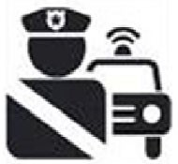
Everyone has the right to be safe from violence. If you or someone you know is in danger, you can seek help from available security services.

133

